# I used Java Swing to show the GUI:

# First：

Run the Studentlogin.java

User: Winston

Password:110150

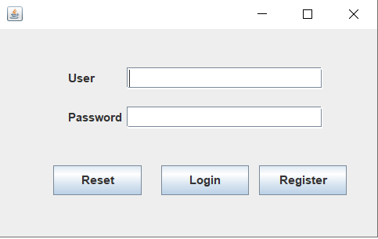

# Second:

It will show the message box then the Mainframe to us:

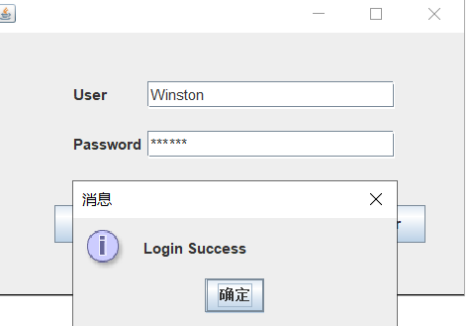

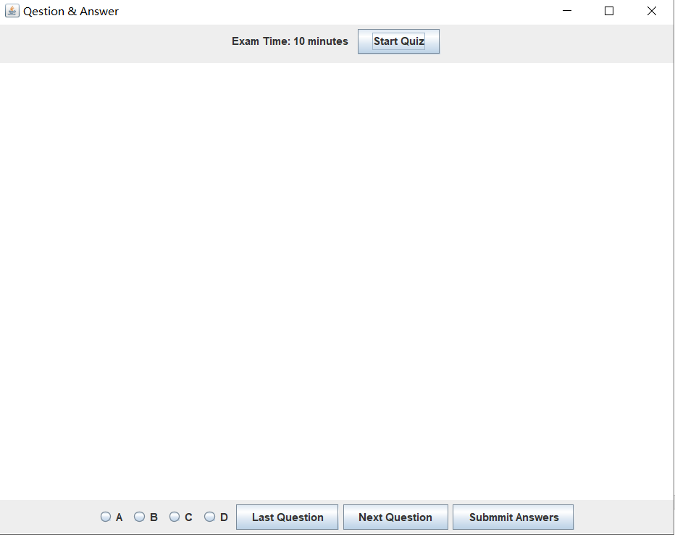

# Third:

Click Start Quiz (the quiz read from a .txt file):

Then will show the quiz and a time counter with 10 minutes:

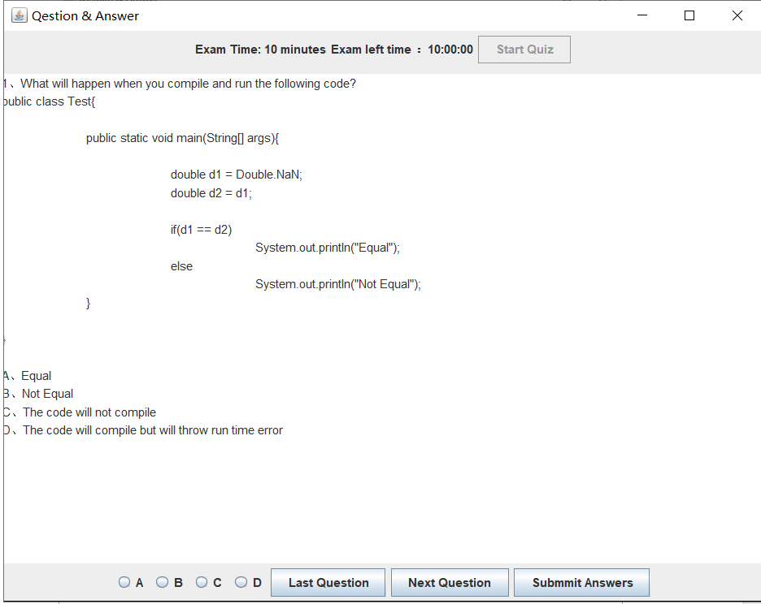

IF already the last question show the message box :

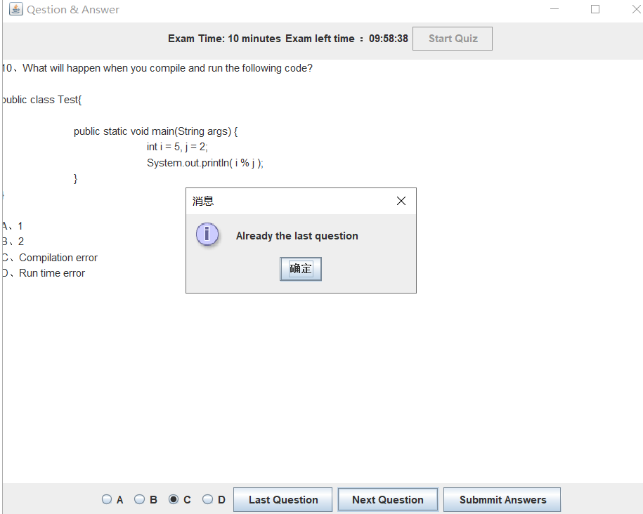

# Last:

Click submit :

After calculating the score then show us the scores we got:

